 | Princess Nourah bint Abdulrahman University  College of Medicine | 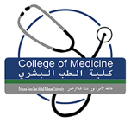

Form for Rechecking of examination
Student ID…………………………………………………………………………………………
Student Name……………………………………………………………………………………..
Name of the Exam : Midterm Final OSPE&PBL OSCE

Name of the Block…………………………………………………………………………………

Attempt of rechecking: First Second Third

Mark/Grade obtained…………………………………………………………………………….

Permission Allowed Not allowed

Mark/Grade obtained (After rechecking) ………………………………………………………

Attempt of remained (After Rechecking) : First Second Third

Remarks: ………………………………………………………………………………………………

Head of Assessment Unit

Signature:……………

Academic Advisor

Signature:……………

Block Chair

Signature:……………

Vice Dean Educational Affairs

Signature:……………

